Aim:To demonstrate the creation of a child process using the fork() system call in Linux.
Description: The fork() system call is used to create a new process by duplicating the calling
process.
 The original process is the parent, and the newly created one is the child.
 Both processes execute the same code but have different process IDs.
 fork() returns:
o > 0 →Parent process (child’s PID is returned)
o 0 →Child process
o < 0 →Error in creating process
Algorithm:
1. Start program execution.
2. Call fork() to create a new process.
3. If fork() returns 0, it’s the child process.
4. If fork() returns a positive value, it’s the parent process.
5. Print process ID for both parent and child.
6. End program.
Program:
#include <stdio.h>
#include <unistd.h>
int main() {
int pid;
pid = fork();
if (pid < 0) {
printf("Fork failed!\n");
} else if (pid == 0) {
printf("This is the child process. PID = %d\n", getpid());
} else {
printf("This is the parent process. PID = %d, Child PID = %d\n", getpid(), pid);
}
return 0;
}
Output:
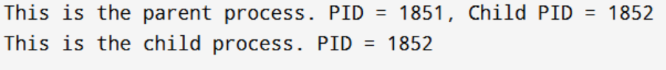
Conclusion: The fork() system call was successfully demonstrated. A parent process and a child process were created, each with unique process IDs.
Aim: To implement the First-Come, First-Served (FCFS) CPU scheduling algorithm.
Description:
 FCFS is the simplest CPU scheduling algorithm.
 Processes are executed in the order they arrive in the ready queue.
 It is non-preemptive.
 Average waiting time is highly affected by the order of process arrival.
Algorithm:
1. Input the number of processes and their burst times.
2. Sort processes by arrival order (if given).
3. Compute waiting time for each process:
WT[i] = CT[i] - AT[i] - BT[i]
4. Compute turnaround time:
TAT[i] = WT[i] + BT[i]
5. Display Gantt chart, waiting times, turnaround times, and averages.
Program:
#include <stdio.h>
int main() {
int n, bt[20], wt[20], tat[20], i;
float avg_wt = 0, avg_tat = 0;
printf("Enter number of processes: ");
scanf("%d", &n);
printf("Enter Burst Time for each process:\n");
for (i = 0; i < n; i++) {
printf("P%d: ", i+1);
scanf("%d", &bt[i]);
}
wt[0] = 0;
for (i = 1; i < n; i++) {
wt[i] = wt[i-1] + bt[i-1];
}
for (i = 0; i < n; i++) {
tat[i] = wt[i] + bt[i];
avg_wt += wt[i];
avg_tat += tat[i];
}
printf("\nProcess\tBT\tWT\tTAT\n");
for (i = 0; i < n; i++) {
printf("P%d\t%d\t%d\t%d\n", i+1, bt[i], wt[i], tat[i]);
}
printf("\nAverage Waiting Time = %.2f", avg_wt/n);
printf("\nAverage Turnaround Time = %.2f\n", avg_tat/n);
return 0;
}
Output:
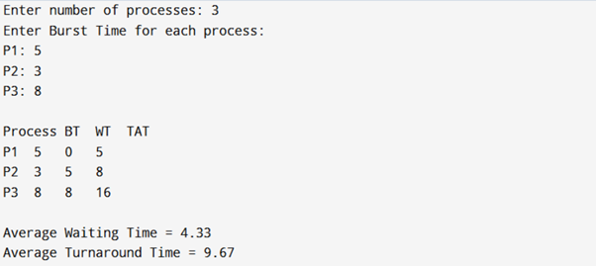
Conclusion:
The FCFS scheduling algorithm was successfully implemented and analyzed.
Aim: To implement the Shortest Job First (SJF) CPU scheduling algorithm.
Description:
 SJF selects the process with the smallest burst time first.
 It reduces average waiting time compared to FCFS.
 Can be preemptive or non-preemptive (here, non-preemptive).
Algorithm:
1. Input processes and burst times.
2. Sort processes in ascending order of burst time.
3. Compute waiting time and turnaround time.
4. Display results with averages.
Program:
#include <stdio.h>
int main() {
int n, bt[20], wt[20], tat[20], p[20], i, j, temp;
float avg_wt = 0, avg_tat = 0;
printf("Enter number of processes: ");
scanf("%d", &n);
printf("Enter Burst Time for each process:\n");
for (i = 0; i < n; i++) {
printf("P%d: ", i+1);
scanf("%d", &bt[i]);
p[i] = i+1;
}
for (i = 0; i < n-1; i++) {
for (j = i+1; j < n; j++) {
if (bt[i] > bt[j]) {
temp = bt[i]; bt[i] = bt[j]; bt[j] = temp;
temp = p[i]; p[i] = p[j]; p[j] = temp;
}
}
}
wt[0] = 0;
for (i = 1; i < n; i++) {
wt[i] = wt[i-1] + bt[i-1];
}
for (i = 0; i < n; i++) {
tat[i] = wt[i] + bt[i];
avg_wt += wt[i];
avg_tat += tat[i];
}
printf("\nProcess\tBT\tWT\tTAT\n");
for (i = 0; i < n; i++) {
printf("P%d\t%d\t%d\t%d\n", p[i], bt[i], wt[i], tat[i]);
}
printf("\nAverage Waiting Time = %.2f", avg_wt/n);
printf("\nAverage Turnaround Time = %.2f\n", avg_tat/n);
return 0;
}
Output:
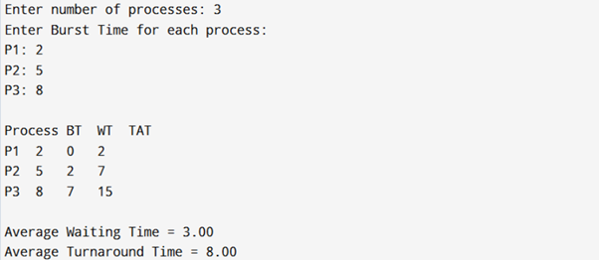
Conclusion:
The SJF scheduling algorithm was successfully implemented and analyzed.

Aim: To simulate the CPU Scheduling using the Priority Scheduling algorithm in C++ and
analyze process execution order based on priority.
Description: CPU Scheduling is the process of selecting a process from the ready queue and
allocating CPU to it.
 Priority Scheduling assigns a priority value to each process.
 The CPU is allocated to the process with the highest priority (lowest priority number
is usually considered highest priority).
 If two processes have the same priority, they are scheduled according to their arrival
order (or FCFS).
Algorithm/Steps:
1. Start the program.
2. Input the number of processes.
3. For each process, input:
o Burst Time
o Priority
4. Sort processes based on their priority (highest priority first).
5. Calculate:
o Waiting Time (WT) for each process
o Turnaround Time (TAT) for each process
6. Compute average WT and TAT.
7. Display the scheduling order and results.
8. End program.
Program:
#include <iostream>
#include <algorithm>
using namespace std;
struct Process {
int pid, bt, priority, wt, tat;
};
// Compare function for sorting based on priority
bool compare(Process a, Process b) {
return (a.priority < b.priority);
}
int main() {
int n;
cout << "Enter number of processes: ";
cin >> n;
Process p[n];
for(int i = 0; i < n; i++) {
p[i].pid = i + 1;
cout << "Enter Burst Time and Priority for Process " << p[i].pid << ": ";
cin >> p[i].bt >> p[i].priority;
}
// Sort processes by priority
sort(p, p + n, compare);
// Calculate Waiting Time and Turnaround Time
p[0].wt = 0;
for(int i = 1; i < n; i++) {
p[i].wt = p[i-1].wt + p[i-1].bt;
}
float avgWT = 0, avgTAT = 0;
for(int i = 0; i < n; i++) {
p[i].tat = p[i].wt + p[i].bt;
avgWT += p[i].wt;
avgTAT += p[i].tat;
}
avgWT /= n;
avgTAT /= n;
cout << "\nProcess\tBT\tPriority\tWT\tTAT\n";
for(int i = 0; i < n; i++) {
cout << p[i].pid << "\t" << p[i].bt << "\t" << p[i].priority
<< "\t\t" << p[i].wt << "\t" << p[i].tat << endl;
}
cout << "\nAverage Waiting Time = " << avgWT;
cout << "\nAverage Turnaround Time = " << avgTAT << endl;
return 0;
}

Output:
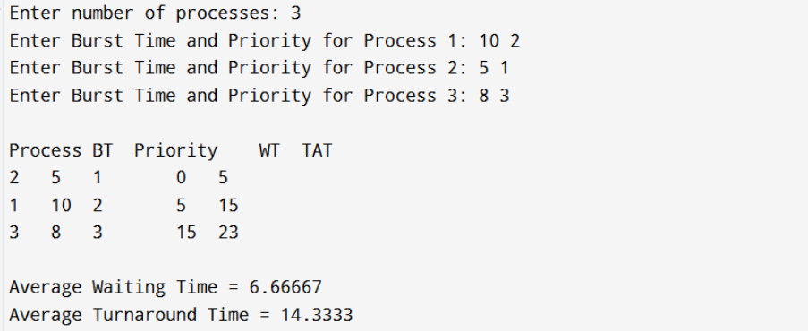
Conclusion: The CPU Scheduling using the Priority Algorithm was successfully simulated in
C++. The program computes Waiting Time and Turnaround Time for each process and
demonstrates how processes are scheduled based on their priority

Aim: To simulate CPU Scheduling using the Round Robin (RR) algorithm in C++ and analyze
process execution order, waiting time, and turnaround time.
Description:
 Round Robin (RR) is a preemptive CPU scheduling algorithm.
 Each process is assigned a fixed time quantum.
 The CPU executes a process for at most one quantum. If the process is not finished, it
is placed at the back of the ready queue.
 This ensures fairness since every process gets CPU time in a cyclic order.
Algorithm/Steps:
1. Start the program.
2. Input the number of processes and their Burst Times.
3. Input the Time Quantum.
4. Initialize a queue for scheduling.
5. Execute each process for the given quantum:
o If a process finishes before the quantum, mark it complete.
o Otherwise, reduce its burst time and move it to the end of the queue.
6. Calculate Waiting Time (WT) and Turnaround Time (TAT) for each process.
7. Compute average WT and TAT.
8. Display process execution details.
9. End program.
Program:
#include <iostream>
#include <queue>
using namespace std;
struct Process {
int pid, bt, rt, wt, tat;
};
int main() {
int n, tq;
cout << "Enter number of processes: ";
cin >> n;
Process p[n];
for(int i = 0; i < n; i++) {
p[i].pid = i + 1;
cout << "Enter Burst Time for Process " << p[i].pid << ": ";
cin >> p[i].bt;
p[i].rt = p[i].bt; // remaining time
}
cout << "Enter Time Quantum: ";
cin >> tq;
int time = 0, completed = 0;
queue<int> q;
for(int i = 0; i < n; i++) q.push(i);
while(!q.empty()) {
int i = q.front();
q.pop();
if(p[i].rt > tq) {
time += tq;
p[i].rt -= tq;
q.push(i); // re-queue the process
} else {
time += p[i].rt;
p[i].wt = time - p[i].bt;
p[i].tat = time;
p[i].rt = 0;
completed++;
} }
float avgWT = 0, avgTAT = 0;
cout << "\nProcess\tBT\tWT\tTAT\n";
for(int i = 0; i < n; i++) {
cout << p[i].pid << "\t" << p[i].bt
<< "\t" << p[i].wt << "\t" << p[i].tat << endl;
avgWT += p[i].wt;
avgTAT += p[i].tat;
}
cout << "\nAverage Waiting Time = " << avgWT / n;
cout << "\nAverage Turnaround Time = " << avgTAT / n << endl; return 0;
}
Output:
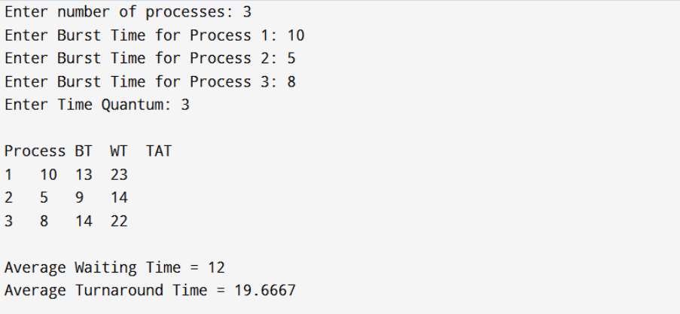
Conclusion: The Round Robin CPU Scheduling algorithm was successfully simulated in C++.

Aim: To simulate the Banker’s Algorithm for deadlock avoidance in C++.
Description:
 The Banker’s Algorithm is used in operating systems to avoid deadlocks by allocating
resources safely.
 It checks if a system is in a safe state before granting resource requests.
Algorithm/Steps:
1. Input number of processes and resources.
2. Input Allocation, Maximum, and Available matrices.
3. Compute Need = Max – Allocation.
4. Apply Banker’s Algorithm to check if the system is in a safe state.
5. If a safe sequence exists, display it; otherwise, report unsafe state.
Program:
#include <iostream>
using namespace std;
int main() {
int n, m;
cout << "Enter number of processes: ";
cin >> n;
cout << "Enter number of resources: ";
cin >> m;
int alloc[n][m], max[n][m], avail[m];
cout << "Enter Allocation Matrix:\n";
for(int i=0;i<n;i++) for(int j=0;j<m;j++) cin >> alloc[i][j];
cout << "Enter Maximum Matrix:\n";
for(int i=0;i<n;i++) for(int j=0;j<m;j++) cin >> max[i][j];
cout << "Enter Available Resources:\n";
for(int i=0;i<m;i++) cin >> avail[i];
int need[n][m], finish[n]={0}, safeSeq[n], work[m];
for(int i=0;i<m;i++) work[i]=avail[i];
for(int i=0;i<n;i++) for(int j=0;j<m;j++) need[i][j]=max[i][j]-alloc[i][j];
int count=0;
while(count<n){
bool found=false;
for(int i=0;i<n;i++){
if(!finish[i]){
int j;
for(j=0;j<m;j++) if(need[i][j]>work[j]) break;
if(j==m){
for(int k=0;k<m;k++) work[k]+=alloc[i][k];
safeSeq[count++]=i;
finish[i]=1;
found=true;
}
}
}
if(!found){ cout<<"System is not in a safe state\n"; return 0; }
}
cout<<"System is in a safe state.\nSafe sequence: ";
for(int i=0;i<n;i++) cout<<"P"<<safeSeq[i]<<" ";
cout<<endl;
return 0;
}
Output:
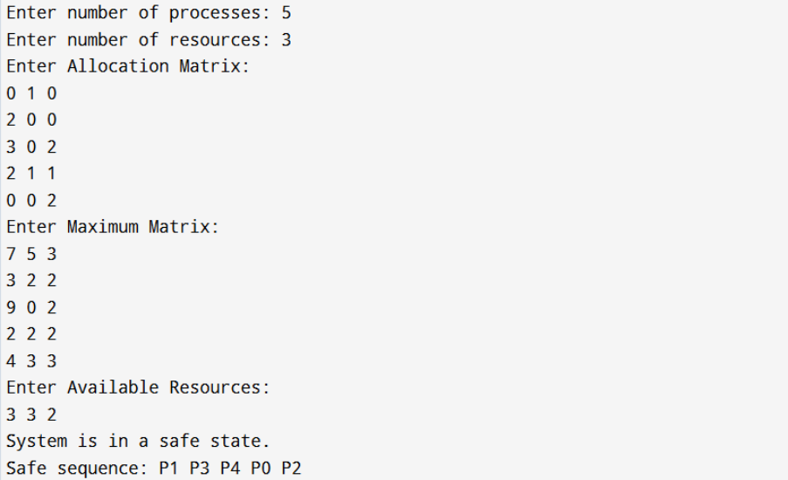
Conclusion: Banker’s Algorithm was successfully implemented to check safe and unsafe
states for deadlock avoidance.

smaller than the partition size.
Aim: To simulate the FIFO page replacement algorithm.
Description: FIFO replaces the oldest page in memory when a new page must be loaded and
no free frames are available.
Algorithm/Steps:
1. Input number of frames.
2. Input page reference string.
3. Load pages sequentially.
4. If page fault occurs and frames are full, replace the oldest page.
Program:
#include <iostream>
#include <queue>
#include <vector>
using namespace std;
int main() {
int n, f, page, faults = 0;
cout << "Enter number of frames: ";
cin >> f;
cout << "Enter number of pages: ";
cin >> n;
vector<int> pages(n);
cout << "Enter reference string: ";
for (int i = 0; i < n; i++) cin >> pages[i];
queue<int> q;
vector<int> frame;
for (int i = 0; i < n; i++) {
page = pages[i];
bool found = false;
for (int x : frame) if (x == page) found = true;
if (!found) {
if (frame.size() < f) frame.push_back(page);
else {
int victim = q.front(); q.pop();
for (int j = 0; j < frame.size(); j++)
if (frame[j] == victim) frame[j] = page;
}
q.push(page);
faults++;
}
cout << "Frames: ";
for (int x : frame) cout << x << " ";
cout << endl;
}
cout << "Total Page Faults: " << faults << endl;
return 0;
}
Output:
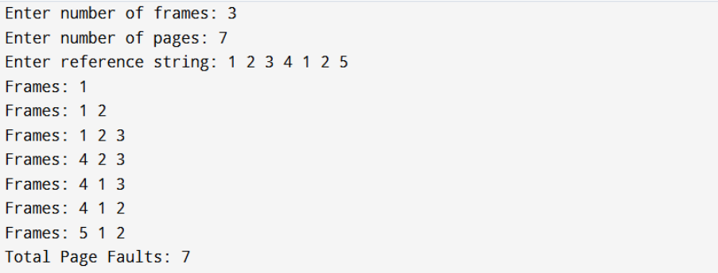
Conclusion: FIFO page replacement was simulated and the number of page faults was
observed.
Aim: To simulate the LRU page replacement algorithm.
Description: Least Recently Used (LRU) replaces the page that has not been used for the
longest time.
Algorithm/Steps:
1. Input number of frames and reference string.
2. Keep track of last used time for each page.
3. Replace the page with the longest idle time when a page fault occurs.
Program:
#include <iostream>
#include <vector>
#include <unordered_map>
using namespace std;
int main() {
int n, f, page, faults = 0;
cout << "Enter number of frames: ";
cin >> f;
cout << "Enter number of pages: ";
cin >> n;
vector<int> pages(n);
cout << "Enter reference string: ";
for (int i = 0; i < n; i++) cin >> pages[i];
vector<int> frame;
unordered_map<int,int> lastUsed;
for (int i = 0; i < n; i++) {
page = pages[i];
bool found = false;
for (int x : frame) if (x == page) found = true;
if (!found) {
if (frame.size() < f) frame.push_back(page);
else {
int lru_index = 0;
int min_last = i;
for (int j = 0; j < frame.size(); j++) {
if (lastUsed[frame[j]] < min_last) {
min_last = lastUsed[frame[j]];
lru_index = j;
}
}
frame[lru_index] = page;
}
faults++;
}
lastUsed[page] = i;
cout << "Frames: ";
for (int x : frame) cout << x << " ";
cout << endl;
}
cout << "Total Page Faults: " << faults << endl;
return 0;
}
Output:
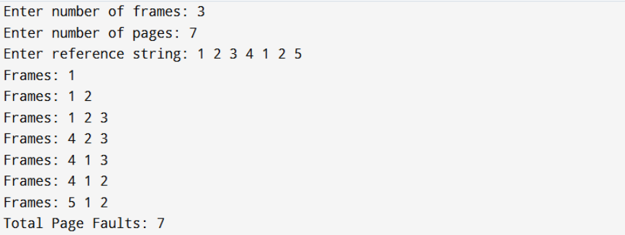
Conclusion: LRU page replacement was simulated and the least recently used page was
replaced on each fault.

